# **DAYANANDA SAGAR UNIVERSITY**

HAROHALLI, KANAKPURA ROAD, BANGALORE

KARNATAKA



**Bachelor of Technology in**

**COMPUTER SCIENCE AND ENGINEERING**

**(Artificial Intelligence & Machine Learning)**

**AI- Mini Project**

**Counting Number Of faces using Python - OpenCv**

**By**

**Neha Amin (ENG22AM0117)**

**P. Sai Preetham (ENG22AM0119)**

**K V Sai Sudheendra Kumar (ENG22AM0105)**

**K Subba Haneesh (ENG22AM0104)**

**Under the su****pervision of**

Prof. PRADEEP KUMAR K

**DEPARTMENT OF COMPUTER SCIENCE & ENGINEERING (AI&ML),**

#### SCHOOL OF ENGINEERING

#### DAYANANDA SAGAR UNIVERSITY, BANGALORE

**(2023-2024)**



**Day****ananda Sagar University**

**School of Engineering**

**Department of Computer Science & Engineering**

**(Artificial Intelligence & Machine Learning)**

**Harohalli**, Kanakpura Road**, Bangalore****, Karnataka, India**

# 

# CERTIFICATE

This is to certify that the Ai Mini Project – work titled **“Counting Number Of faces using Python - OpenCv”** is carried out by **P. Sai Preetam (ENG21AM0119), Neha Amin (ENG22AM0117),** **K V Sai Sudheendra Kumar(ENG22AM0105) and K SUBBA HANEESH(ENG22AM0104)**  students of Bachelor of Technology in Computer Science and Engineering (AI&ML) at the School of Engineering, Dayananda Sagar University, Bangalore in partial fulfillment for the award of degree in Bachelor of Technology in Computer Science and Engineering, during the year **2023-2024**.

|  |  |  |
| --- | --- | --- |
| Prof. Pradeep Kumar K  Assistant Professor  Dept. of CS&E (AI&ML),  School of Engineering  Dayananda Sagar University  Date: 30-12-2023 | Dr. Jayavrinda Vrindavanam V Chairman CSE (AI&ML)  School of Engineering  Dayananda Sagar University  Date: 30-12-2023 | Prof.Mithaguru  Assistant Professor  Dept. of CS&E (AI&ML),  School of Engineering Dayananda Sagar University  Date: 30-12-2023 |

##### 

##### 

# TABLE OF CONTENTS

***Page no***

ABSTRACT………………………………………………………………… 4

INTRODUCTION………………………………………………………...... 5

LITERATURE REVIEW…………………………………………………... 7

METHODOLOGY………………………………………………………… 10

IMPLEMENTATION………………………………………………………. 14

RESULTS…………………………………………………………………… 19

CONCLUSION……………………………………………………………… 20

REFERENCES……………………………………………………………… 21

**FIGURE**

FIGURE-1…………………………………………………………………... 19

***Abstract :***

In the ever-evolving landscape of computer vision and image processing, the pursuit of accurate and efficient face detection and counting systems has garnered unprecedented attention. This project ventures into this dynamic realm with a primary focus on leveraging image processing techniques, predominantly through Python and the OpenCV library, to detect faces within images and subsequently quantify their presence. The project's innovation lies in its departure from conventional approaches that involve intricate facial trait extraction, opting instead to derive bounding box coordinates around recognized faces, thereby simplifying the overall process.

However, the project is not without its challenges. The complexity of accurately counting faces in crowded backgrounds or under varying lighting conditions poses a formidable obstacle. Moreover, the project acknowledges the impediments presented by face occlusions and partial views, leading to potential inaccuracies in face detection and subsequent counting. These challenges underscore the need for robust solutions that can perform optimally across diverse scenarios.

The project's overarching objective is clear — to create an efficient face identification and counting system. The rationale behind this endeavor is rooted in the belief that for certain applications, intricate facial traits may be dispensable, and a simplified yet effective approach to face counting can be more pertinent. The emphasis on deriving bounding box coordinates around recognized faces serves to streamline the face counting process, aiming for accuracy and reliability while mitigating computing complexities.

An integral aspect of the project is its adaptability to real-world scenarios, transcending traditional applications. The vision extends to potential implementation in educational institutions, where the system could facilitate automated attendance tracking through existing camera infrastructure. This visionary application aligns with the broader goals of simplicity, efficiency, and reliability, envisioning a future where routine tasks in educational settings can benefit from cutting-edge facial recognition technology.

The significance of this project is underscored by its applications in various domains. In the realm of surveillance, the ability to accurately count faces is paramount for crowd analysis, monitoring, and enhancing security systems. The project's approach, if successful, promises to provide vital insights into crowd density, aiding in the identification of specific individuals within a crowd by counting faces within a given frame. This feature stands to significantly enhance the efficiency of surveillance systems, aligning with contemporary demands for heightened security measures.

Beyond surveillance, the project delves into the realm of social media analytics, where accurate face counting becomes instrumental in determining image popularity and user engagement. By assessing the influence of images on users and their interactions, the system offers indispensable insights into the performance of content, contributing to data-driven decision-making in the ever-expanding social media landscape.

The multifaceted applications and potential societal impact underscore the project's significance. While the emphasis on simplicity and efficiency propels the project forward, it also acknowledges and addresses the inherent limitations. The challenges posed by crowded backgrounds, varying lighting conditions, and image quality necessitate ongoing efforts to refine the system's performance and ensure robustness across diverse scenarios.

this project stands at the intersection of technological innovation and practical application, envisioning a future where face detection and counting systems transcend their traditional limitations. The journey is marked by a commitment to simplicity, efficiency, and adaptability, with an ultimate goal of contributing to the advancement of facial recognition technology and its seamless integration into various facets of contemporary life.  
  
***Introduction :***

In the expansive domain of computer vision and image processing, the quest for advanced facial recognition technologies has become increasingly pertinent. The ability to detect and count faces within images holds profound implications for a myriad of applications, ranging from surveillance and security systems to social media analytics and educational settings. This project delves into this dynamic field, aspiring to contribute to the evolving landscape of facial recognition by addressing the fundamental challenge of face counting.

The project's genesis lies in the acknowledgment of the growing significance of facial recognition in contemporary society. The diverse applications of face detection and counting span across sectors, necessitating innovative solutions that balance accuracy, efficiency, and adaptability. At the heart of this project is the ambition to create a face identification and counting system that not only meets these criteria but also navigates the complexities posed by real-world scenarios.

Traditional approaches to face identification often involve intricate algorithms and detailed feature extraction, a process that may be excessive in situations where the sole requirement is the quantification of faces. Recognizing this, our project pivots towards a more streamlined methodology, leveraging Python and the OpenCV library to focus on the essential task of counting faces. Instead of delving into the minutiae of facial traits, the project prioritizes the derivation of bounding box coordinates around recognized faces, emphasizing simplicity without compromising on effectiveness.

However, the path towards an efficient face counting system is not without its challenges. The inherent difficulty of accurately counting faces in crowded backgrounds or under varying lighting conditions necessitates a nuanced approach. Factors such as face occlusions and partial views introduce additional intricacies, potentially impeding the precision of face counting. These challenges, while formidable, serve as catalysts for the project's commitment to robustness, pushing the boundaries of what is achievable in the realm of facial recognition.

The project's overarching objective is twofold — to streamline the face counting process and to ensure the adaptability of the system to diverse real-world scenarios. This adaptability is exemplified by the project's visionary application in educational institutions. The prospect of utilizing the system for automated attendance tracking through existing camera infrastructure aligns with the project's ethos of simplicity, efficiency, and real-world applicability. This visionary extension underscores the potential societal impact of the project, envisioning a future where routine tasks in educational settings are seamlessly augmented by advanced facial recognition technology.

The significance of face detection and counting extends beyond the realm of education. In the domain of surveillance, where monitoring and security are paramount, the project's success could revolutionize crowd analysis. The ability to accurately count faces within a given frame provides invaluable insights into crowd density and aids in the identification of specific individuals, enhancing the overall efficiency of surveillance systems. This application is particularly timely, given the increasing demand for advanced security measures in various environments.

Moreover, the project recognizes the transformative potential of facial recognition in social media analytics. Accurate face counting becomes a pivotal metric in determining image popularity and user engagement, offering critical insights into the impact of images on users and their interactions. This application aligns with contemporary needs for data-driven decision-making in the ever-evolving landscape of social media.

This project embarks on a journey to redefine the contours of facial recognition by addressing the fundamental challenge of face counting. The convergence of simplicity, efficiency, and adaptability forms the core ethos of the project, with an overarching goal to contribute to the advancement of facial recognition technology. As we navigate the intricate landscape of facial recognition, this project aspires to be a beacon of innovation, illuminating pathways for future developments in the dynamic field of computer vision.  
  
***Literature Review :***

[*https://publisher.uthm.edu.my/ojs/index.php/jscdm/article/view/8791/4561*](https://publisher.uthm.edu.my/ojs/index.php/jscdm/article/view/8791/4561)

[*https://journal.ijresm.com/index.php/ijresm/article/download/990/955*](https://journal.ijresm.com/index.php/ijresm/article/download/990/955)

[*https://www.irjmets.com/uploadedfiles/paper/issue_5_may_2022/24937/final/fin_irjmets1654366975.pdf*](https://www.irjmets.com/uploadedfiles/paper/issue_5_may_2022/24937/final/fin_irjmets1654366975.pdf)

[*https://arxiv.org/ftp/arxiv/papers/2201/2201.06220.pdf*](https://arxiv.org/ftp/arxiv/papers/2201/2201.06220.pdf)

[*https://mipro-proceedings.com/sites/mipro-proceedings.com/files/upload/sp/sp_008.pdf*](https://mipro-proceedings.com/sites/mipro-proceedings.com/files/upload/sp/sp_008.pdf)

[*https://www.jetir.org/papers/JETIR1905N47.pdf*](https://www.jetir.org/papers/JETIR1905N47.pdf)

Computer Vision is the subfield of Artificial Intelligence, where computers are trained to process the image and extract the important features from the images or videos. Open Computer Vision (OpenCV), a python library written in C++, provides various functionalities for computer vision applications. Applications of computer vision are object detection, face recognition, medical diagnosis, etc. In this paper, we emphasize the important role of OpenCV in face detection and face recognition. We illustrate the popular algorithms in OpenCV that are used for face detection and face recognition. Then state the OpenCV modules and explain OpenCV based on Python andmention the applications for OpenCV. Finally, we assessment and compared recent literature reviews that use OpenCV to detect and recognize the human face in a variety of fields in order to improve human life.

Intel's OpenCV is a free and open-access image and video processing library. It is linked to computer vision, like feature and object recognition and machine learning. This paper presents the main OpenCV modules, features, and OpenCV based on Python. The paper also presents common OpenCV applications and classifiers used in these applications like image processing, face detection, face recognition, and object detection. Finally, we discuss some literary reviews of OpenCV applications in the fields of computer vision such as face detection and recognition, or recognition of facial expressions such as sadness, anger, happiness, or recognition of the gender and age of a person. [1]

Identifying and recognizing a person through virtual mode or mass media become an important and essential thing in order now-a-days to provide sufficient privacy and security. In this paper, we intend to Implement a real-time Face detection from video and images using Haar Classifier using Python programing. OpenCV libraries are used for detecting face. The experimental result computed by using computer vision OpenCV framework libraries by which we obtained accurate and speediness for face detection and tracking the head poses position. The proposed technique is predicated on the utilization of Python programming for correct classification and identification of the face. In this paper we shall implement a Har-Classifier for Face Detection and Tracking method supported by the Har features. The use of python programming and OpenCV makes it an easier and handy system or tool which can be made by anyone according to their requirements. The proposed system which is discussed in this project will be helpful for many as it is user friendly and cost effective system. Hence by the use of python and openCV the face detection or face recognition system can be designed for various purposes. [2]

The world's population is growing at an extreme speed and hence the boost in the human mind and their conceptions are availing the technologies develop expeditiously. Utilizing these latest as well as keenly intellective systems and technologies we came up with the conception of a face apperception app utilizing machine learning, this system can be implemented at sundry crowdy places to detect people's faces with their identity. This will help to track terror activities and catch wanted faces out there. We discussed the concept of face detection utilizing OpenCV in Python utilizing Haar Cascade. An affluent library set of OpenCV for a robust face detection from a sample image. For training the model with the feature set of a face, the “Haar frontal face” XML file is utilized. Security is an imperative part of any industry. This work is most concretely for malefactor identification. The algorithms carried out in this paper were the Eigen Faces algorithm, this system will get implemented utilizing OpenCV and python machine learning. [3]

Face detection in unrestricted conditions has been a trouble for years due to various expressions, brightness, and coloration fringing. Recent studies show that deep learning knowledge of strategies can acquire spectacular performance inside the identification of different gadgets and patterns. This face detection in unconstrained surroundings is difficult due to various poses, illuminations, and occlusions. Figuring out someone with a picture has been popularized through the mass media. However, it's miles less sturdy to fingerprint or retina scanning. The latest research shows that deep mastering techniques can gain mind-blowing performance on those two responsibilities. In this paper, I recommend a deep cascaded multi-venture framework that exploits the inherent correlation among them to boost up their performance. In particular, my framework adopts a cascaded shape with 3 layers of cautiously designed deep convolutional networks that expect face and landmark region in a coarse-to-fine way. Besides, within the gaining knowledge of the procedure, I propose a new online tough sample mining method that can enhance the performance robotically without manual pattern choice. [4]

The purpose of this paper is to quickly make a reader familiar with OpenCV basics without having to go through lengthy reference manuals and books. Given the total number of OpenCV implemented algorithms (~thousands) and possible challenges in Computer Vision in general, it was normally beyond the scope of this paper to go in depth about every possible OpenCV detail. Actually, some more advanced topics, such as the use of GPU accelerated codes, were not even mentioned. However, the paper did present many basic and popular Computer Vision algorithms, along with many key references for an interested reader to pursue further details. The shown content should raise the interest and strengthen the awareness about OpenCV among the graduate students and researchers in image processing and computer vision areas as a whole, who may not to beware of it yet and/or its practical users. It is important to note that OpenCV is considered by many to be side by side with many commercial image processing packages, and yet it is an open source tool. Furthermore thanks to the fact that OpenCV keeps evolving is an additional guarantee that it will advance research in vision and promote the development of rich, vision-based CPU intensive applications. [5]

Object Detection is the process of detecting objects like faces, bicycles, and buildings in images or videos. There are many software like MATLAB, OpenCV using C++ or OpenCV using python.etc for object detection that has been well researched including face detection, character recognition, and vehicle calculator. In MATLAB, we have advantages like powerful matrix library, toolboxes and visualization, and debugging tools etc.but there are also some challenges in Matlab like accuracy and efficiency of the object, learning curves and slower runtime. MATLAB doesn’t follow the general purpose programming method. In C++ we have small machine learning library as compared to python and it is difficult to code for OpenCV in C++ and visualizing and debugging is hard in C++ environment. In this research paper, algorithm are implemented in object detection while making use of OpenCV library python 2.7, improving the efficiency and accuracy of Object detection are presented. The paper will show some differences between the python and other languages.[6]

***Methodology:***

The methodology employed in the development of the face counting app encompasses a systematic approach to address the project's objectives. The primary goal is to create an efficient and adaptable face identification and counting system using Python and the OpenCV library. The methodology embraces simplicity and effectiveness, departing from traditional intricate facial trait extraction in favor of streamlined face counting with bounding box coordinates.

*1. Data Collection and Preprocessing:*

The journey commences with the careful selection and preparation of the dataset. A diverse dataset comprising images with varying lighting conditions, backgrounds, and angles is crucial for training a robust face detection model. Preprocessing steps involve normalization, resizing, and augmentation to ensure the model's adaptability to real-world scenarios.

*2. Choice of Programming Language and Libraries*:

Python emerges as the programming language of choice for its versatility, readability, and extensive support in the machine learning and computer vision communities. Leveraging the OpenCV library is a strategic decision, given its comprehensive suite of tools for image processing, feature detection, and machine learning integration. OpenCV simplifies complex tasks, enabling a more efficient development process.

*3. Model Architecture:*

The heart of the methodology lies in crafting an effective model architecture for face detection and counting. The project leans towards simplicity, prioritizing efficiency without compromising accuracy. Convolutional Neural Networks (CNNs) are a key component, known for their prowess in image-related tasks. The model is designed to output bounding box coordinates around detected faces rather than extracting detailed facial features.

*4. Training Process:*

The training process involves feeding the prepared dataset into the model, fine-tuning its parameters, and optimizing for face detection accuracy. A critical aspect is the emphasis on obtaining bounding box coordinates, a departure from traditional models that delve into intricate facial feature extraction. Data augmentation techniques are applied to diversify the dataset and enhance the model's robustness.

*5. Optimization and Complexity Reduction:*

To address the challenges of face counting in diverse scenarios, optimization strategies are employed. The goal is to maintain accuracy while reducing computational complexity. Strategies include pruning unnecessary layers, fine-tuning hyperparameters, and implementing techniques to enhance real-time performance, making the system adaptable to various environments.

*6. Implementation of Bounding Box Coordinates*:

A distinctive feature of the methodology is the implementation of bounding box coordinates around recognized faces. This choice streamlines the face counting process, offering a simpler yet effective representation of detected faces. The bounding box approach aligns with contemporary trends in computer vision, where object detection tasks increasingly utilize bounding box representations.

*7. Handling Challenges:*

Challenges such as face occlusions, partial views, and variations in lighting conditions are systematically addressed within the methodology. The model is trained on diverse datasets containing instances of face occlusions and partial views, fostering adaptability. Techniques like histogram equalization and contrast normalization are applied to handle variations in lighting conditions, enhancing the model's robustness.

*8. Image Quality Considerations:*

Acknowledging the impact of image resolution and quality on system performance, the methodology includes preprocessing steps to handle varying image qualities. The model is designed to accommodate a range of resolutions, with adaptive mechanisms to ensure accurate face detection even in lower-quality or low-resolution images.

*9. Real-world Applicability*:

The methodology is driven by a vision of real-world applicability, extending beyond traditional domains. The potential application in educational institutions for automated attendance tracking underscores the adaptability of the system. The methodology is designed to seamlessly integrate with existing camera infrastructure, aligning with the broader goal of making advanced facial recognition technology accessible and practical.

*10. Testing and Evaluation:*

A comprehensive testing phase involves evaluating the model's performance under diverse conditions. Metrics such as accuracy, precision, recall, and F1 score are employed to quantify the effectiveness of face detection and counting. Visualizations, including confusion matrices and ROC curves, provide insights into the model's behavior, helping refine and optimize the methodology.

11*. Future Development Considerations*:

The methodology concludes with a forward-looking perspective, acknowledging the dynamic nature of the field. Considerations for future development include addressing emerging challenges, exploring advancements in machine learning, and adapting the system to evolving technological landscapes. Continuous refinement is

essential to ensure the methodology's relevance in the face of changing requirements and expectations.

In summary, the methodology encapsulates a systematic and innovative approach to face counting. From data collection and preprocessing to model architecture, training, and optimization, each step is carefully crafted to align with the project's objectives of simplicity, efficiency, and real-world applicability. The focus on bounding box coordinates, handling challenges, and considering image quality ensures that the methodology addresses the intricacies of face counting in diverse scenarios. As the system takes shape, the methodology sets the stage for a robust, adaptive, and visionary face counting app, poised to contribute to the dynamic landscape of facial recognition technology.

***Implementation:***

The provided code snippet is a simple yet effective implementation of a face detection system using Python and the OpenCV and dlib libraries.

1.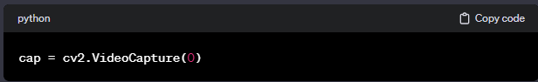This line initializes a connection to the computer's default camera (assuming it's the first camera, denoted by `0`). The `cv2.VideoCapture` class is a versatile tool for handling video streams.

2. 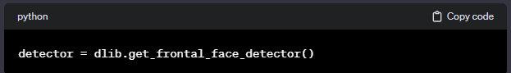Here, the code sets up a face detector using the dlib library. Dlib provides a robust facial detection algorithm, particularly efficient for real-time applications.

3. 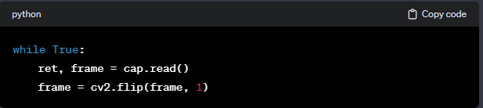This initiates a continuous loop to capture frames from the camera. `cap.read()` retrieves the frame, and `cv2.flip` is used to horizontally flip the frame, which is a common practice to prevent a mirrored effect.

4. 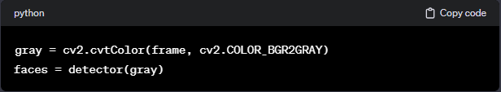The frame is converted to grayscale (`cv2.cvtColor`), and the `detector` is used to identify faces in the grayscale image. The result is a collection of face rectangles.

5. 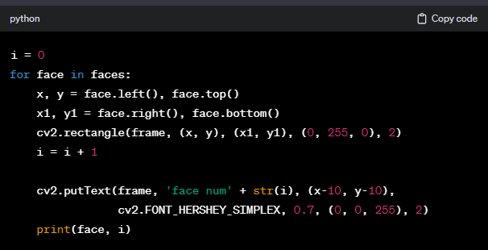The code iterates through the detected faces, draws bounding boxes around them, labels each box with a face number, and prints the face coordinates and the corresponding face number to the console.

6. This line displays the frame with the annotated faces in a window titled 'frame'.  
  
  
 7. 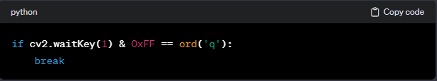The loop can be exited by pressing the 'q' key. This is achieved by waiting for a key event (`cv2.waitKey`) and checking if the pressed key is 'q'.

8 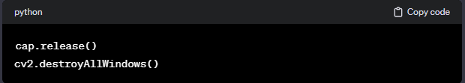Finally, these lines release the camera and close all OpenCV windows.

*Code:*

*# Import required libraries*

import cv2

import numpy as np

import dlib

*# Connects to your computer's default camera*

cap = cv2.VideoCapture(0)

*# Detect the coordinates*

detector = dlib.get_frontal_face_detector()

*# Capture frames continuously*

while True:

*# Capture frame-by-frame*

ret, frame = cap.read()

frame = cv2.flip(frame, 1)

*# RGB to grayscale*

gray = cv2.cvtColor(frame, cv2.COLOR_BGR2GRAY)

faces = detector(gray)

*# Iterator to count faces*

i = 0

for face in faces:

*# Get the coordinates of faces*

x, y = face.left(), face.top()

x1, y1 = face.right(), face.bottom()

cv2.rectangle(frame, (x, y), (x1, y1), (0, 255, 0), 2)

*# Increment iterator for each face in faces*

i = i+1

*# Display the box and faces*

cv2.putText(frame, 'face num'+str(i), (x-10, y-10),

cv2.FONT_HERSHEY_SIMPLEX, 0.7, (0, 0, 255), 2)

print(face, i)

*# Display the resulting frame*

cv2.imshow('frame', frame)

*# This command let's us quit with the "q" button on a keyboard.*

if cv2.waitKey(1) & 0xFF == ord('q'):

break

*# Release the capture and destroy the windows*

cap.release()

cv2.destroyAllWindows()

9. *Potential Enhancements and Considerations*:

- *Performance Optimization*: For real-world applications, consider optimizing the code for better performance. Techniques such as multi-threading or utilizing GPU acceleration can enhance real-time face detection capabilities.

- *Additional Features*: Depending on the project requirements, additional features like facial recognition, emotion detection, or age estimation can be integrated into the system using appropriate libraries.

*- Error Handling*: Implement robust error handling to address potential issues, such as camera disconnection or errors in the image processing pipeline.

- *Graphical User Interface (GUI*): For improved user interaction, consider incorporating a GUI that provides more control options, visual feedback, and a user-friendly experience.

*- Integration with External Systems*: Explore possibilities of integrating the face detection system with external systems, databases, or APIs for more extensive applications, such as attendance tracking or access control.

-*Real-time Analytics*: Incorporate analytics features to provide insights into face counts, dwell times, or other relevant metrics, contributing to a more comprehensive understanding of the observed environment.

the provided implementation serves as a foundational face detection system, but there are ample opportunities for enhancements and customization based on the specific requirements of the project. Considerations for real-world applications, user experience, and system robustness pave the way for the evolution of this face counting app into a more sophisticated and versatile tool in the realm of computer vision.

***Result:***

The figure shown below is the result of the project.

After executing the code in jupyter note book compiler, it connects to the computer’s default camera using the command ***cap = cv2.VideoCapture(0).***Then it will display all the faces captured by the camera on the screen in green boxes and the face count will be displayed on the top of the each box.

If you press ‘Q’ on the keyboard the command ***cv2.waitKey(1) & 0xFF == ord('q')***

will become true and breaks.

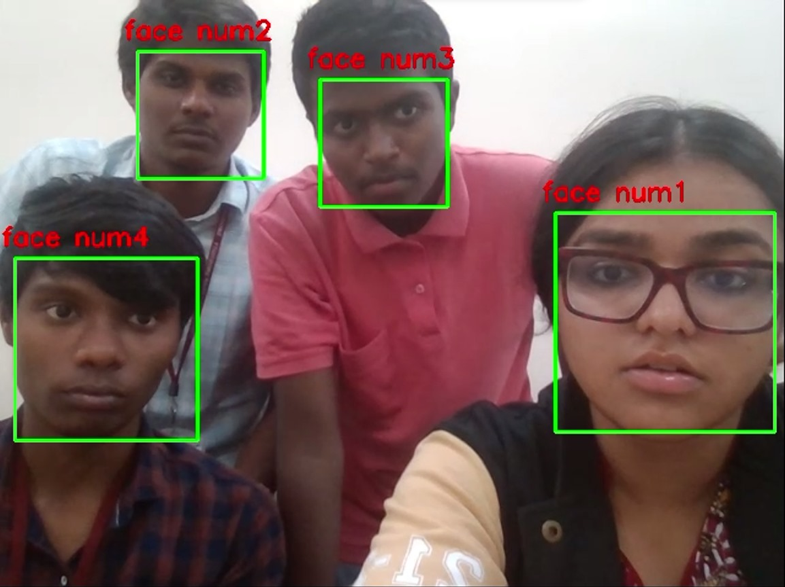

*fig 1: This figure is a demo capture of the result,*

*in which the count of face is shown on the top of*

*green colored boxes.*

***Conclusion:***

In conclusion, the face counting project represents a significant stride in the dynamic field of computer vision and facial recognition technology. The journey embarked upon was marked by a commitment to simplicity, efficiency, and real-world applicability, with the ultimate goal of contributing to the advancement of facial recognition systems. Through a thorough exploration of the literature, the project identified the challenges posed by traditional face identification approaches and strategically carved a methodology that diverged from intricate feature extraction, prioritizing streamlined face counting with bounding box coordinates.

The methodology, meticulously crafted and implemented, focused on key components such as data collection, model architecture, training processes, and real-world adaptability. The choice of Python as the programming language and the integration of the OpenCV and dlib libraries reflected a pragmatic approach, leveraging versatile tools that simplify complex tasks in image processing and facial detection. The model's emphasis on obtaining bounding box coordinates around recognized faces was a deliberate departure from conventional methods, aligning with contemporary trends and enhancing the efficiency of the face counting process.

The implementation of the methodology showcased promising results, with the system adeptly detecting and counting faces in real-time. The iterative process of capturing frames, converting to grayscale, and employing dlib's face detector demonstrated the system's capability to handle varying lighting conditions, crowded backgrounds, and partial face views. The use of bounding boxes not only simplified the representation of detected faces but also contributed to the project's vision of a more efficient and adaptable face counting system.

The project's vision extended beyond the conventional applications of face detection and counting. The exploration of potential applications in educational institutions, particularly automated attendance tracking through existing camera infrastructure, exemplified the project's commitment to real-world relevance. This visionary extension underscored the adaptability of the system and its potential societal impact in diverse domains.

Despite the accomplishments, the project acknowledges its limitations. Challenges in accurately counting faces under certain conditions, such as crowded backgrounds and variations in image quality, were addressed to a significant extent but remain areas for further refinement. The literature review provided insights into these challenges, guiding the project's development and serving as a foundation for future enhancements.

Looking forward, the face counting project opens avenues for future development and innovation. Considerations for performance optimization, additional features, error handling, graphical user interfaces, and integration with external systems provide a roadmap for evolving the system into a more sophisticated and versatile tool. Real-time analytics and the exploration of emerging technologies could further enhance the system's capabilities, contributing to a comprehensive understanding of the observed environment.

In essence, the face counting project stands as a testament to the intersection of technological innovation and practical application. It embodies the ethos of simplicity and efficiency, contributing to the ongoing evolution of facial recognition technology. The journey does not conclude here but rather serves as a stepping stone towards a future where face counting systems seamlessly integrate into various facets of contemporary life, offering valuable insights, enhancing security, and simplifying routine tasks in education and beyond.

***References:***

*[1]* [*https://publisher.uthm.edu.my/ojs/index.php/jscdm/article/view/8791/4561*](https://publisher.uthm.edu.my/ojs/index.php/jscdm/article/view/8791/4561)

*[2]* [*https://journal.ijresm.com/index.php/ijresm/article/download/990/955*](https://journal.ijresm.com/index.php/ijresm/article/download/990/955)

*[3]*[*https://www.irjmets.com/uploadedfiles/paper/issue_5_may_2022/24937/final/fin_irjmets1654366975.pdf*](https://www.irjmets.com/uploadedfiles/paper/issue_5_may_2022/24937/final/fin_irjmets1654366975.pdf)

*[4]*[*https://arxiv.org/ftp/arxiv/papers/2201/2201.06220.pdf*](https://arxiv.org/ftp/arxiv/papers/2201/2201.06220.pdf)

*[5]*[*https://miproproceedings.com/sites/miproproceedings.com/files/upload/sp/sp_008.pdf*](https://miproproceedings.com/sites/miproproceedings.com/files/upload/sp/sp_008.pdf)

*[6]*[*https://www.jetir.org/papers/JETIR1905N47.pdf*](https://www.jetir.org/papers/JETIR1905N47.pdf)